DAY 1 PROBLEMS:

1. Consider the set of 5 processes whose arrival time and burst time are given below If the CPU scheduling policy is FCFS,

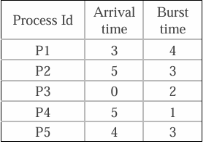

calculate the average waiting time and average turnaround time.

PROGRAM:

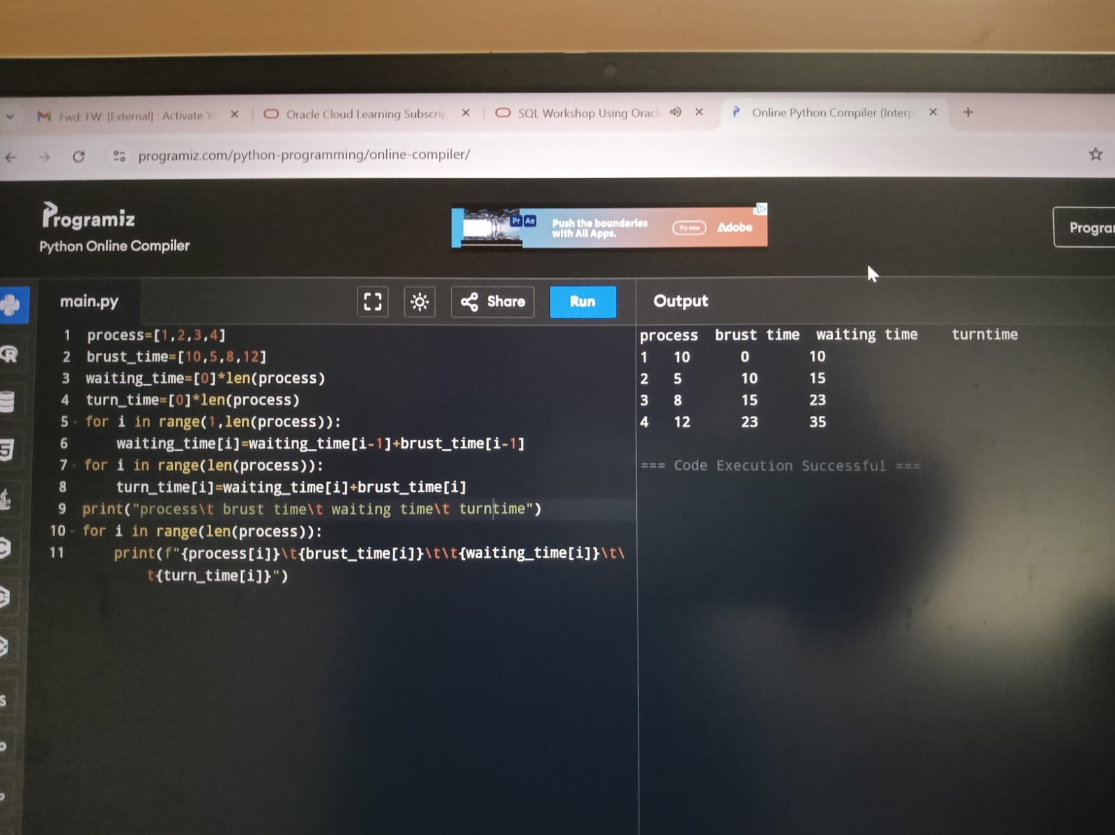

1. Consider the set of 5 processes whose arrival time and burst time are given below If the CPU scheduling policy is SJF non-preemptive,

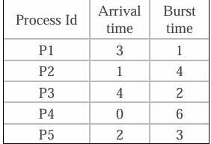

calculate the average waiting time and average turn around time.

Program:

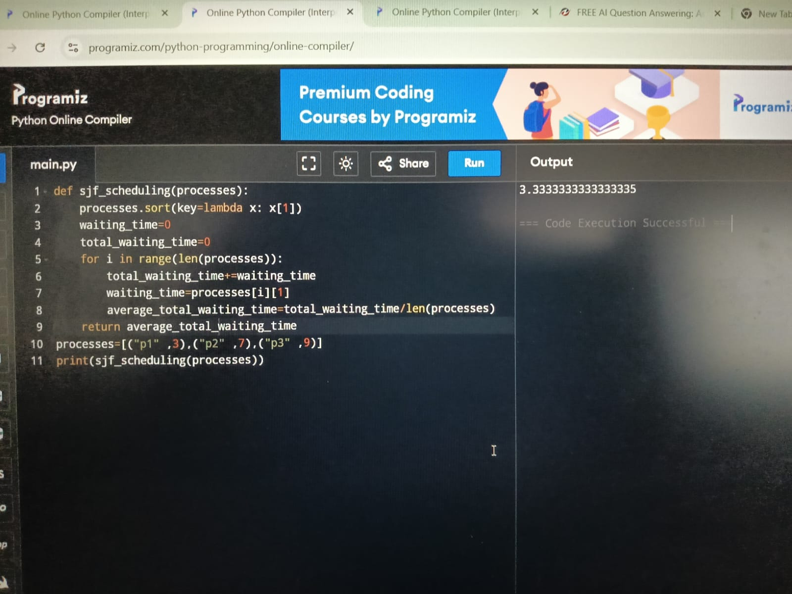

1. Consider the set of 5 processes whose arrival time and burst time are given below

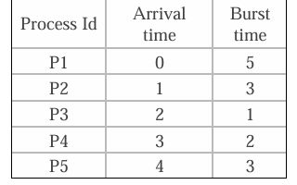

If the CPU scheduling policy is Round Robin with time quantum = 2 unit, calculate the average waiting time and average turn around time.

Program:

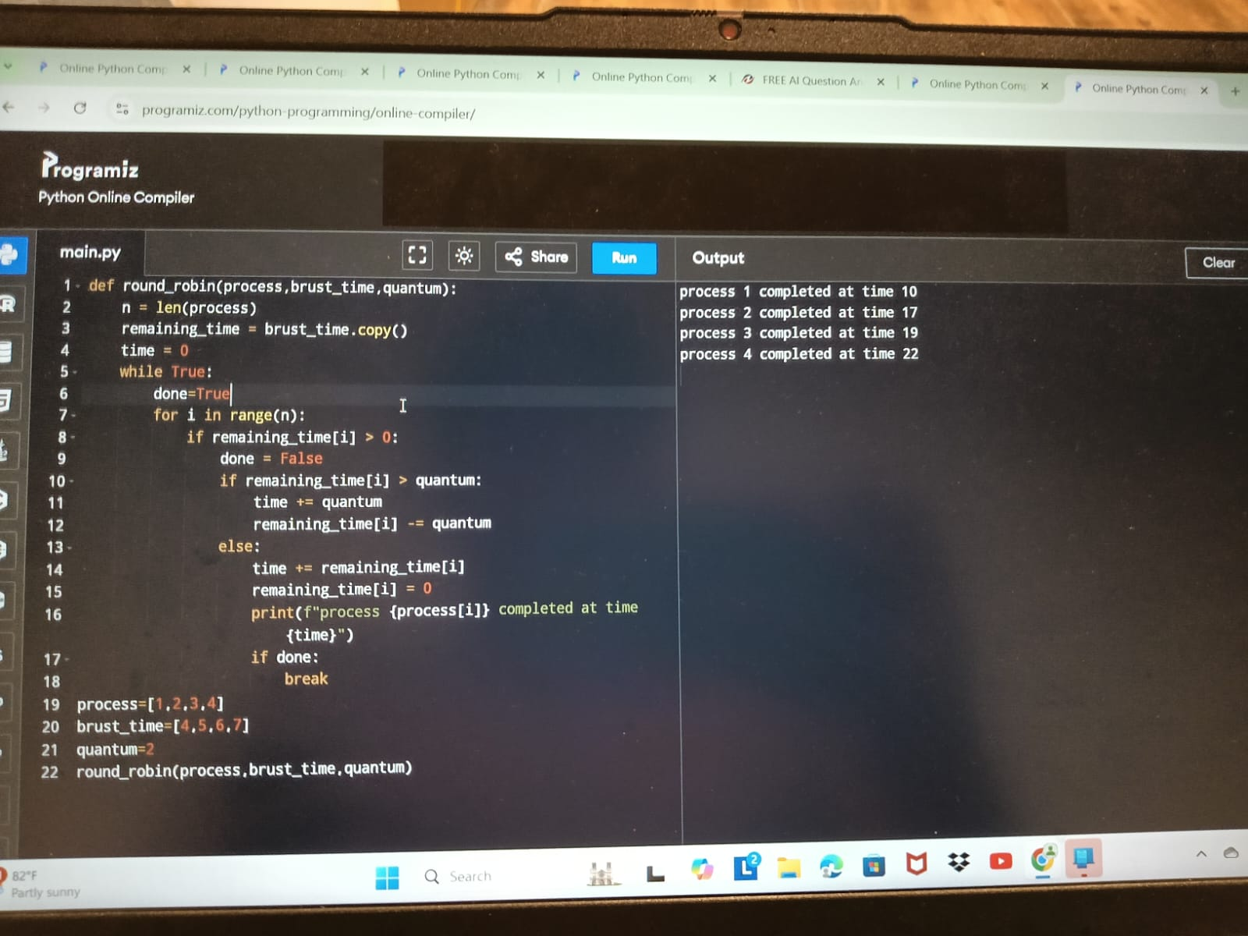

1. Consider the set of 5 processes whose arrival time and burst time are given below

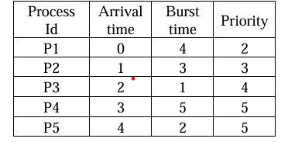

If the CPU scheduling policy is priority non-preemptive, calculate the average waiting time and average turnaround time. (Higher number represents higher priority)

Program:

